Tellus eVV User Upload Instructions
The Tellus eVV Solution allows you to upload User (Caregiver) and User (Member, Patient) information, details as follows.
Note: If you have a smaller number of Users and/or users, then you may wish to simply enter them using the screens provided in the Tellus eVV Provider Portal. If you have a larger number of each, then you may wish to use file upload.
The templates that we provide below are in comma-separated-value (CSV) format, you can edit them with either Microsoft Excel, Google Sheets, or a notepad application.
It is important that you follow the instructions below carefully, and that you do not change any of the fields/columns in the template.

USERS:
In some limited cases, Tellus may receive a User feed directly from the payer and will automatically populate the User information. In cases where the payer does not provide a feed, you can upload all your Users at one time using the Tellus CSV template.

In the same e-mail you received this Upload Instruction Guide, you will have also received two different excel files, saved as a .csv file, the following will make for a successful User file upload:
- Open the excel with the file name TellusEvvUsersUploadTemplate.csv
***Important*** This file includes one row of sample data for an example to work for you to follow. Please remember to delete this row before uploading.
- Each column in the excel file has specific rules about what is an acceptable entry, the rules are explained in more detail below.

- Keep in mind, when you edit this template in Excel or Google Sheets, you must save the file as .csv file before uploading.
Column A – Users First Name
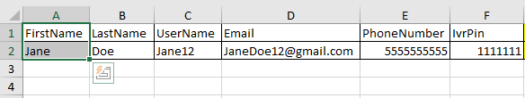
- FirstName is a mandatory field
- FirstName allows for letters and spaces only (no numbers or special characters)
- FirstName must be 255 characters in length or less
Column B – Users Last Name
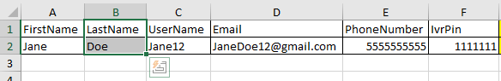
- LastName is a mandatory field
- LastName allows for letters and spaces only (no numbers, spaces or special characters)
- LastName must be 255 characters in length or less
Column C – UserName
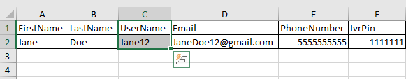
- UserName is a mandatory field
- UserName allows for letters, numbers, and special characters
- UserName must be 255 characters in length or less

Column D – Email
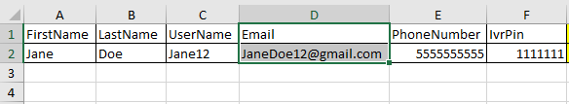
- Email is a conditional field. Either Email or Phone Number must be populated.
- Email must have an “@” and “.”
- Email must be 255 characters in length or less
- Example: Johndoe12!@gmail.com

Column E – PhoneNumber
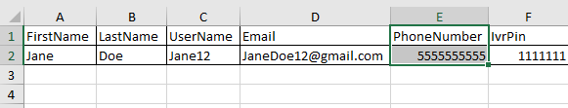
- Phone Number is a conditional field. Either Email or Phone Number must be populated.
- Phone Number must contain only numbers
- Phone Number must be 10 numeric characters in length
Column F – Users IvrPin
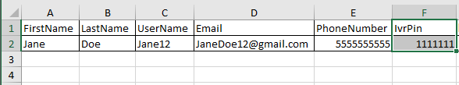
- IvrPin is an optional field.
- IvrPin allows for numbers only, (no spaces, or special characters)
- IvrPin must be 7 numeric characters in length

Column G – Users MedicaidID
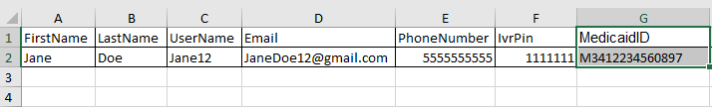
- MedicaidID is an optional field
- MedicaidID must be 9 - 13 digits in length, and allows for numbers and letters only, (no spaces, or special characters)
- There should not be any spaces BEFORE the MedicaidID number starts, for example: “123456789” is valid, and “ 123456789” is not valid because there is a space before the “1”
- If MedicaidID starts with zero, add letter “M” in front to keep leading Zero. Some applications remove zero after saving as .CSV, Our application will remove letter “M” after import is successful.
Column H – UserRole
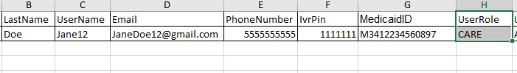
- UserRole is mandatory
- UserRole may only contain the specific 4 letter code for the following:
PRAD (Provider Administrator)
CARE (Caregiver) *note mobile login only
PMON (Provider Monitor) *note Admin permission with read only access

Column I – UserStatus
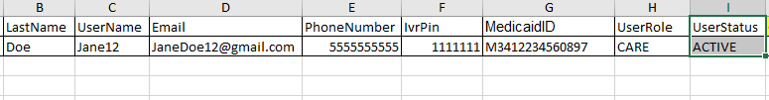
- UserStatus is a mandatory field
- UserStatus may only contain the specific values as follows:
ACTIVE (Can login)
INACTIVE (Not allowed to login)
Column J – CaregiverType
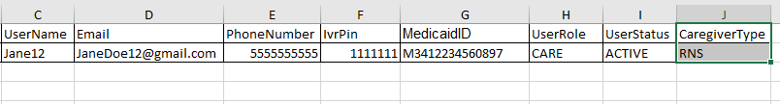
- CaregiverType is a mandatory field
- CaregiverType may only contains the specific 3-4 letter code for the following:
CNA (Certified Nursing Assistant)
LPN (Licensed Practical Nurse)
RNS (Registered Nurse)
ABA (Assistant Behavior Analyst)
RBT (Registered Behavior Technician)
LA (Lead Analyst)
OTHR (Other)

Now that you have entered the information for your Users into the template, you are ready to load your User into the Tellus eVV Provider Portal by following the below steps:
- Make sure you have deleted the sample row from the Users list you just finished creating
- Make sure you have saved the document as a .csv file
- Go to https://4tellus.com/ and click the login button in the upper-right corner of your screen, it will look like this:
- You will be navigated to the Login Screen, it will look like this:
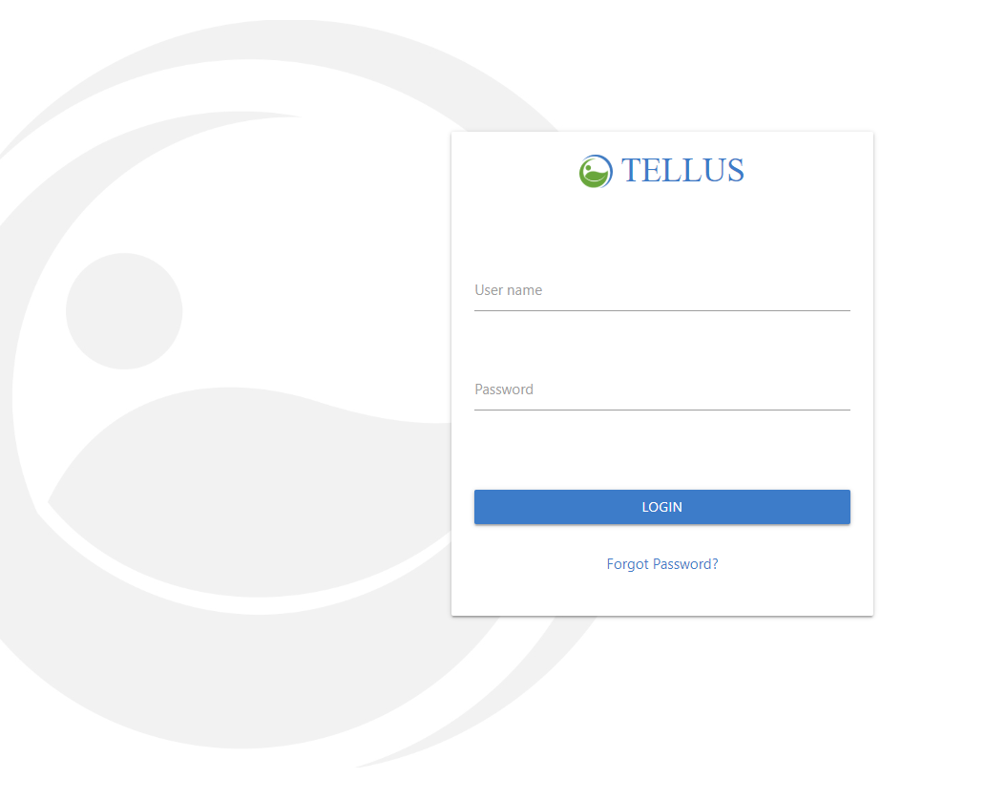
- Navigate to the menu on the left side of the screen and select ‘Users’
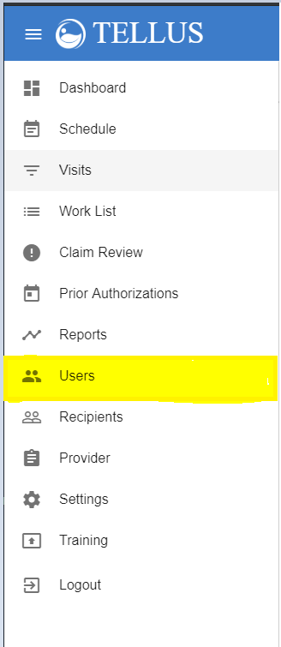

- In the upper right-hand corner, click on the cloud with the up arrow:
- A screen will pop-up asking you to locate the .csv file on your computer, once located, click it
- The upload process will begin once the file is selected
- Upon successful upload, a small green box in the bottom right-hand of your screen will quickly show, saying ‘Success’
    - Your screen will also update and you should see your Users populated below the headers:
- If any errors are identified, a message containing the exact row(s) and column(s) of the error will be shown on your screen.
    - Please refer back to the guide above in order to troubleshoot the exact error(s)

***IMPORTANT***: If there are any errors detected by the system, no records from your file will upload, the entire file must be error free before any User records will upload.

